MSc BDS – Data Engineering and Machine Learning Operations in Business

MLOps Final Assignment:
AI-Driven Retail Demand Forecasting and Smart Inventory Optimization

Submitted by: Anzuman Ara
Student ID: 20241266

Submission Deadline: May 26, 2026

1. Introduction and Aim of the Project
Retail businesses often face difficulties in managing inventory because customer demand changes frequently due to seasonal trends, promotions, holidays, and customer purchasing behavior. In retail environments, inaccurate demand forecasting can lead to overstocking, higher operational costs, and unnecessary food waste
This project presents a real-world MLOps pipeline for retail demand forecasting and smart inventory optimization. The system combines historical Walmart retail sales data with API-based ingestion, preprocessing, feature engineering, machine learning-based forecasting, monitoring, drift detection, retraining, deployment, and dashboard visualization within a single pipeline.
In this project, retail inventory events were continuously sent through APIs and processed inside the pipeline to simulate a real-world retail setup. The project also demonstrates how inventory optimization and demand forecasting may support better stock planning and help reduce potential overstock-related food waste.
Since the Walmart dataset does not contain real food expiry or waste-related attributes, additional inventory-related variables such as current_stock, expiry_days, and waste_quantity were synthetically generated for demonstration purposes. These engineered features were used to simulate operational inventory optimization and waste-risk monitoring scenarios within a practical MLOps environment.
The system aims to support retail decision-making by improving stock planning efficiency, reducing overstock risk, and supporting operational sustainability through waste-risk monitoring.

2. Pipeline Diagram
Historical Walmart Dataset
↓
Preprocessing + Feature Engineering
↓
Model Training + Model Comparison+Best Model Selection
↓
Model Registry + Saved Model
↓
FastAPI Backend
↓
Prediction Endpoint /predict-demand
↓
Model Inference
↓
Prediction Logs + Waste Risk + Recommendation
↓
Drift Detection+If Drift Detected
↓
Automatic Retraining
↓
Updated Model Registry
External Retail System
↓
POST /sales-event
↓
FastAPI Backend
↓
SQLite Operational Database
Streamlit Dashboard connects to:
- prediction results
- latest sales
- model info
- drift reports
- retraining actions
Figure 1: End-to-end MLOps pipeline architecture for retail demand forecasting and waste-risk monitoring.

3. Technical Details of Each Pipeline Component
3.1 Historical Data Collection
The Walmart Store Sales Forecasting dataset from Kaggle was used as the historical training dataset. The dataset contains historical retail sales information across multiple Walmart stores and departments, including holiday-related effects and retail-related variables.
Since the dataset does not contain inventory expiry or food waste information, additional inventory-related variables were synthetically generated to simulate inventory optimization and food waste monitoring workflows.
The generated variables include:
- current_stock
- expiry_days
- unit_price
- waste_quantity
- category labels
- promotional indicators
These additional variables helped simulate realistic retail inventory conditions for the MLOps pipeline.
3.2 Preprocessing
The preprocessing stage ensures consistency between training and inference.
The preprocessing pipeline reads sales records directly from the SQLite database and performs several transformation and cleaning operations before model training.
The following preprocessing steps are applied:
• missing value handling
• numerical type conversion
• duplicate removal
• categorical encoding
• invalid value handling
• outlier safety handling
• feature engineering
SQLite was selected because it provides lightweight structured storage and integrates easily with Python-based machine learning pipelines.
Consistent preprocessing is important in MLOps systems because training-serving mismatch may reduce prediction reliability. Therefore, the same preprocessing logic is reused during both training and prediction stages.
3.3 Feature Engineering
Feature engineering was applied to capture inventory behavior, sales patterns, retail conditions, and food waste risk.
The following engineered features were created:
- product_encoded
This feature converts Walmart department identifiers into numerical values so that machine learning models can process product-level retail patterns.
- category_encoded
This feature converts retail category labels into numerical representations to capture operational differences between store categories.
- short_expiry
This binary feature identifies products with limited remaining shelf life. Products with shorter expiry periods have higher probability of becoming unsold inventory and contributing to potential food waste.
- promotion_active
This feature is derived directly from the promotion indicator and shows whether a promotional campaign is active.
- is_weekend
This feature captures weekend purchasing behavior because retail demand often changes during weekends compared to weekdays.
- day_of_week
This feature captures daily purchasing patterns across the retail week to improve forecasting consistency.
- stock_to_sales_ratio
This feature was calculated as current_stock divided by units_sold to estimate relative inventory pressure and identify possible overstock conditions.
- waste_risk_score
This feature combines inventory level, demand level, and expiry-related conditions into a simplified operational waste-risk indicator for inventory monitoring.
The same feature engineering logic is reused during both training and prediction to reduce training-serving skew.
3.4 Model Training
Multiple candidate models, including RandomForestRegressor and LightGBMRegressor, were evaluated during training. The best-performing model was selected automatically based on RMSE performance. RMSE was used as the primary model selection metric because it penalizes large forecasting errors more strongly than MAE.
A Random Forest regression model was selected for demand forecasting because it performs effectively on structured retail datasets and can capture non-linear operational relationships.
The target variable used for training is units_sold, representing future product demand.
The training pipeline begins by loading the processed dataset and separating the target variable from input features. The dataset is then divided into training and testing subsets using train_test_split to evaluate model performance on unseen records.
After training, the model generates predictions on the test set.
The model is evaluated using:
• MAE (Mean Absolute Error)
• RMSE (Root Mean Squared Error)
• R² Score
MAE measures average prediction error, RMSE penalizes larger prediction errors, and R² evaluates how well the model explains demand variability. After successful training, artifacts including trained models, feature schemas, and evaluation metrics are stored for reproducibility and deployment.
Structured artifact storage was implemented to organize trained models, metrics, drift reports, and monitoring outputs.

3.5 Real-Time Data Ingestion
The data ingestion component was designed to simulate a practical retail workflow. Instead of directly inserting records into the database through standalone scripts, the system uses API-based ingestion.
An external client simulates a supermarket operational system by generating sales and inventory events and sending them to the FastAPI backend through the /sales-event endpoint. Incoming API requests are validated using Pydantic schema models before insertion into the SQLite database.
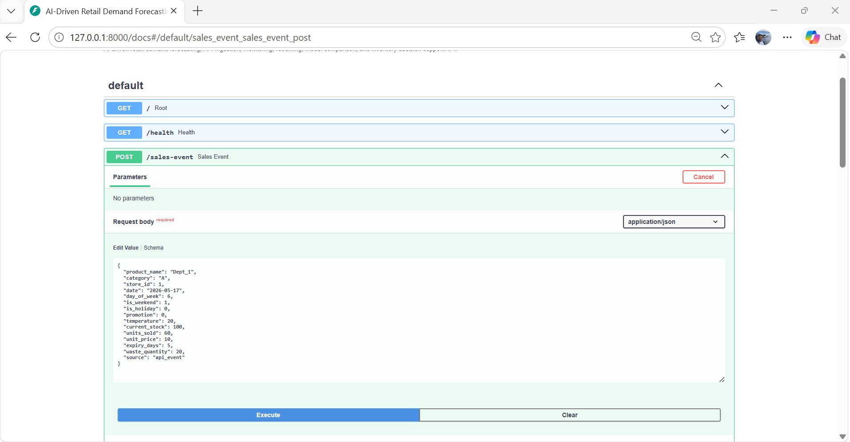
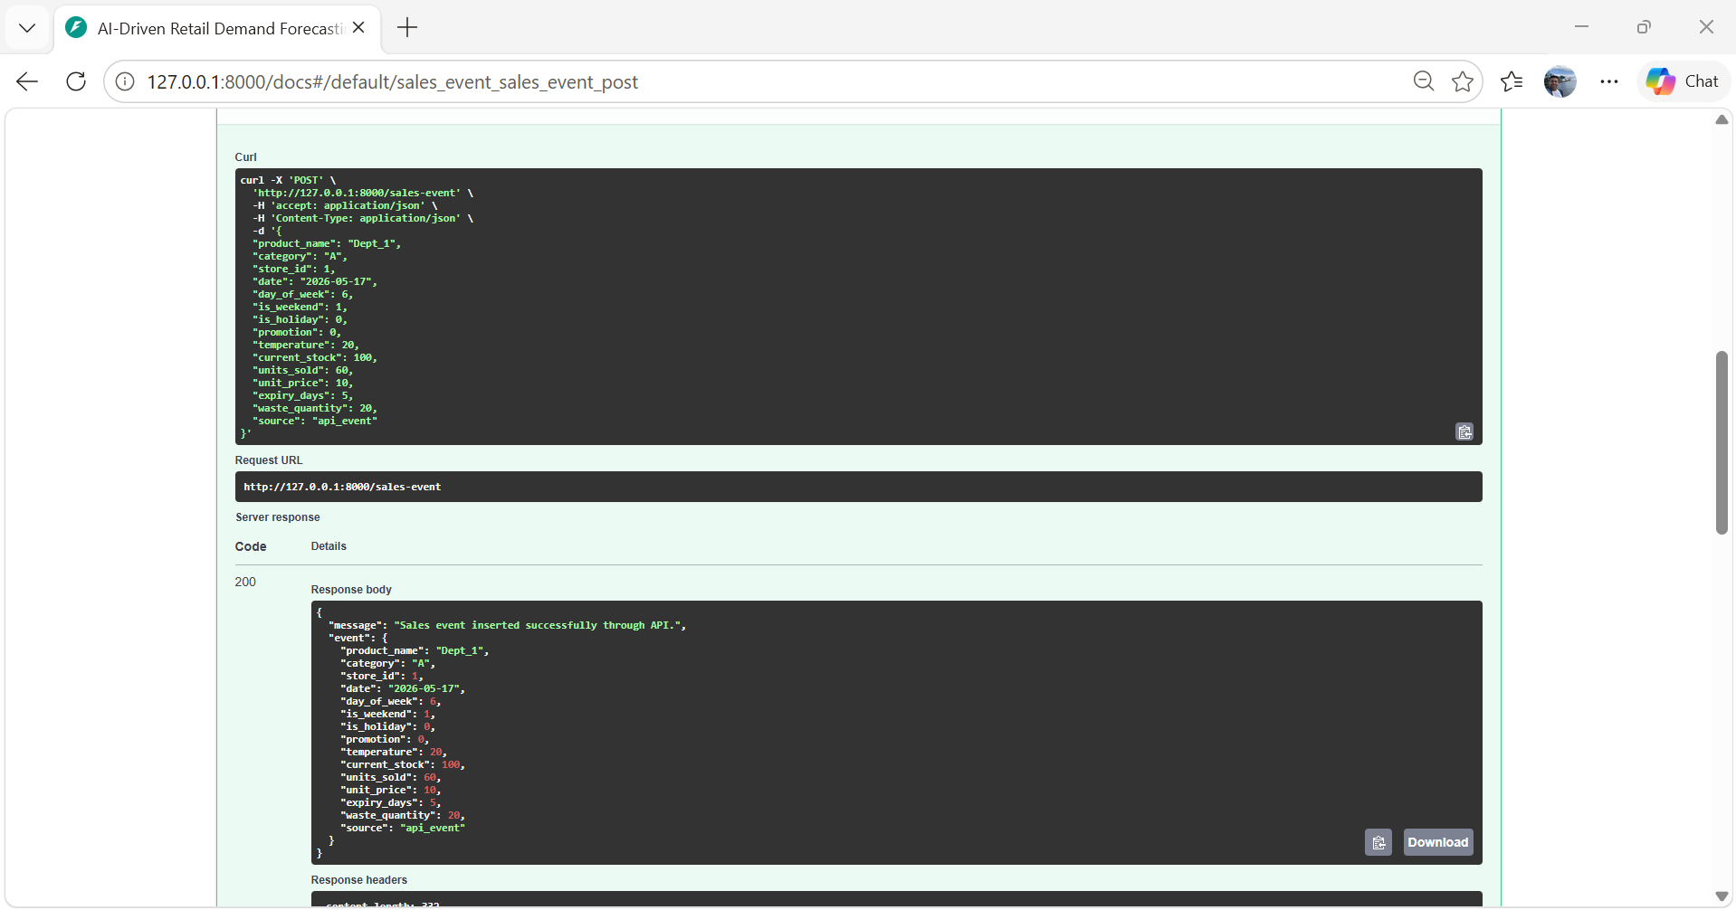
Figure 2: Production-style API ingestion workflow using the FastAPI /sales-event endpoint.
Each generated retail event is validated by the FastAPI backend and then stored inside the SQLite raw_food_sales table. This simulates how real retail systems continuously stream inventory data into machine learning pipelines.
The FastAPI API validates incoming data using structured schemas and stores the validated records inside the SQLite raw_food_sales table.
The Walmart Store Sales Forecasting dataset from Kaggle was integrated into the system as historical training data. The dataset contains historical sales information across multiple Walmart stores and departments, including holiday-related effects and operational retail features.
Additional API endpoints such as /latest-sales were implemented to support production-like ingestion and data validation workflows. Since the dataset does not contain real inventory expiry or food waste information, additional inventory-related variables such as current_stock, expiry_days, unit_price, and waste_quantity were synthetically generated to simulate inventory optimization and waste-risk analysis workflows within a practical MLOps environment.

3.6 Prediction Workflow
After model training, the deployed FastAPI backend provides prediction services through the /predict-demand endpoint. Incoming prediction requests are validated and transformed using the same feature construction logic used during training.
The prediction workflow includes feature construction, model inference, waste-risk estimation, inventory recommendation generation, and prediction logging.
The system predicts future product demand and combines predicted demand with current stock and expiry information to estimate waste risk. Based on this result, the system generates inventory recommendations to support retail decision-making.
Prediction outputs are stored in the prediction_logs table for monitoring and traceability.
4. Evaluation, Monitoring, and Versioning Strategy
4.1 Evaluation
Model performance is evaluated using multiple regression metrics including MAE, RMSE, and R² Score.
The latest training run achieved:
• MAE ≈ 253
• RMSE ≈ 704
• R² ≈ 0.90
The evaluation metrics were calculated using predictions generated on the testing subset after the train-test split process. The model performance was evaluated by comparing predicted units_sold values against actual units_sold values from unseen retail records. Scikit-learn evaluation functions including mean_absolute_error, mean_squared_error, and r2_score were used to calculate the final regression performance metrics.
Using multiple metrics provides a better understanding of model performance compared to relying on a single metric alone.
4.2 Monitoring
Monitoring is implemented at multiple operational levels.
First, prediction logs are stored to maintain traceability of predictions, timestamps, waste risk outputs, and inventory recommendations.
Second, ingestion activity is monitored through incoming records stored in the raw_food_sales table.
Third, automated drift detection was implemented to monitor changes in retail operational behavior over time.
Retail conditions may change over time due to seasonal demand, customer behavior, or inventory fluctuations. Because of these changes, the incoming operational data may gradually differ from the historical training data used by the model. This issue is known as data drift. To address this issue, the system performs numerical feature drift detection using relative mean shift analysis. A lightweight relative mean-shift approach was selected to provide computationally efficient a lightweight relative mean-shift approach was used for drift monitoring within the pipeline.
The following operational features are monitored:
• units_sold
• current_stock
• temperature
• waste_quantity
The drift detection process compares historical reference data with newly incoming retail data batches.
For each monitored feature, the system calculates the relative difference between historical mean values and recent incoming mean values. If the drift score exceeds a predefined threshold (0.15), the system identifies the feature as drifted and generates a drift report.
This approach helps detect operational changes such as:
• unusual sales spikes
• abnormal inventory behavior
• changing temperature conditions
• sudden increases in food waste levels
If significant drift is detected, the system can automatically trigger retraining using updated retail data. This helps maintain model reliability and prediction quality over time.
The drift reports are stored inside the drift_reports table and can also be visualized through the Streamlit dashboard for monitoring purposes.
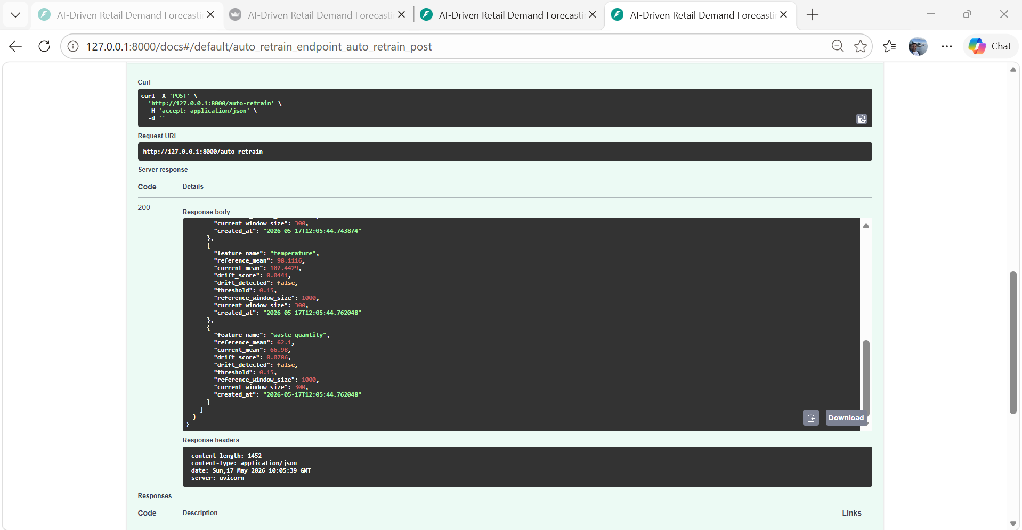
Figure 3: Drift monitoring output showing operational distribution changes across monitored retail features.
The auto_retrain.py workflow automatically checks whether operational drift exceeds the configured threshold. If significant drift is detected, preprocessing and model retraining are executed automatically. Otherwise, retraining is skipped to avoid unnecessary computational overhead.
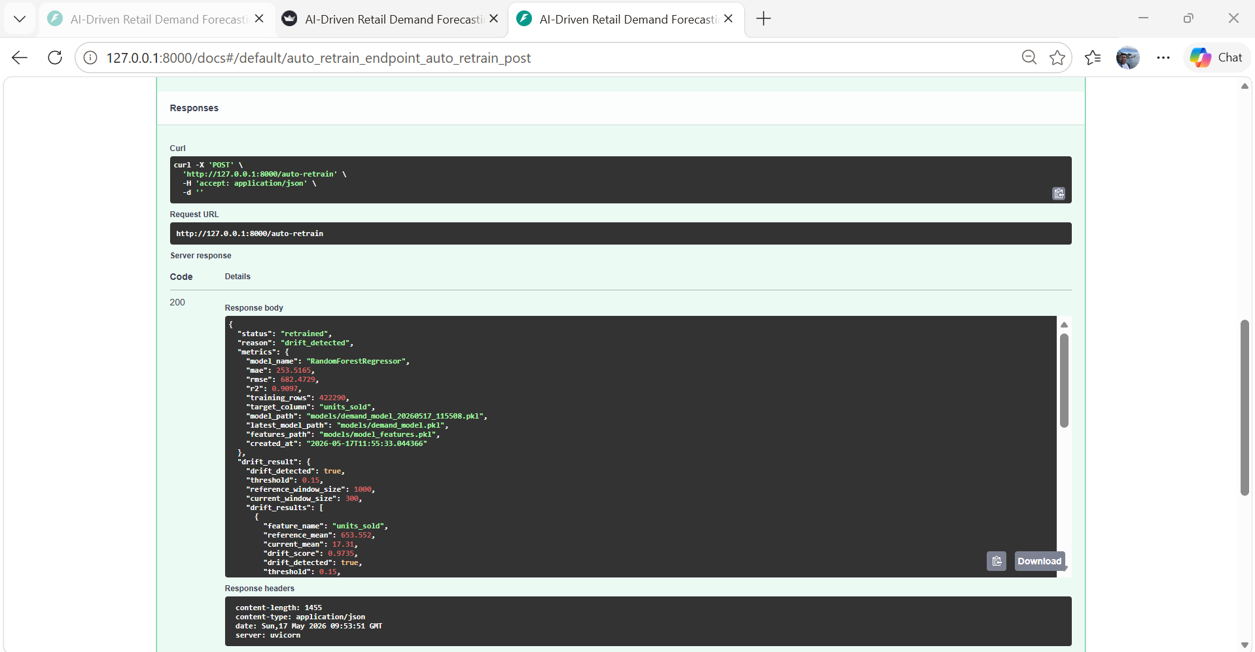
Figure 4: Automatic retraining workflow based on drift monitoring results.
To validate the monitoring workflow, shifted operational retail events were intentionally injected into the system through the API ingestion pipeline. The resulting distribution changes triggered the drift detection mechanism and automatically activated the retraining workflow. This experiment demonstrates how the system can adapt to changing operational retail conditions through monitoring-driven retraining.
4.3 Versioning
Artifact organization and lightweight version tracking were implemented using structured artifact storage and a SQLite model registry table.
Each successful training run stores:
• trained model files
• feature schema files
• evaluation metric files
• prediction logs
• drift reports
A lightweight model registry table was also implemented inside SQLite to track model versions, timestamps, and performance metrics.
Versioning supports reproducibility, rollback, debugging, and model comparison across multiple training runs.

5. Artifact Collection and Storage
The project stores models, logs, and processed data separately so that previous experiments and outputs can be tracked more easily.
Artifacts are stored inside structured directories to maintain separation between models, logs, processed data, and monitoring outputs.
Stored artifacts include:
• raw historical retail data
• processed datasets
• trained model files
• evaluation metrics
• feature schema files
• prediction logs
• drift reports
• retraining outputs
This storage strategy supports reproducibility by making it possible to recreate previous experiments and compare model performance across different pipeline executions. Structured artifact storage improves experiment reproducibility, rollback capability, debugging, and auditability.
The artifact strategy also improves debugging and operational traceability.
Artifact | Purpose
demand_model.pkl | Trained forecasting model
model_features.pkl | Feature schema
drift_summary.csv | Drift monitoring results
model_metrics.csv | Model evaluation metrics
training_summary.json | Training configuration
ingestion_log.csv | API ingestion history
retraining_log.csv | Retraining decisions

6. Deployment Setup
6.1 API Deployment
The trained model was deployed using FastAPI. FastAPI was used to deploy the trained model because it supports efficient API development for Python-based machine learning applications. The FastAPI backend exposes production-style REST API endpoints for ingestion, prediction, monitoring, drift detection, retraining, and pipeline execution. Swagger documentation was automatically generated to support endpoint testing and API inspection.
The system exposes multiple endpoints including:
• /sales-event
• /predict-demand
• /run-pipeline
• /prediction-logs
• /drift-check
• /drift-reports
• /auto-retrain
• /model-info
These endpoints support both prediction and operational monitoring.
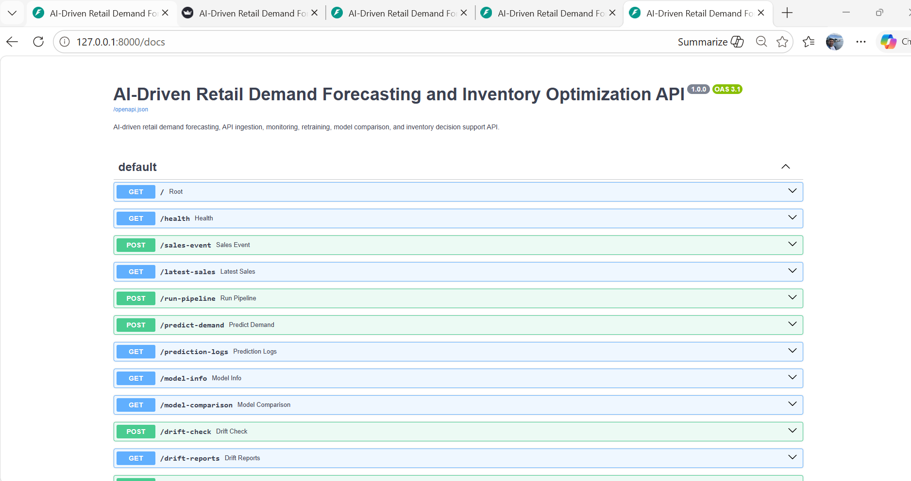
Figure 5: FastAPI Swagger documentation showing deployed API endpoints.
The deployed API allows external systems and dashboards to interact with the machine learning pipeline through standardized HTTP endpoints.
6.2 Docker Deployment
The application supports Docker-based deployment to improve portability and deployment consistency across environments. Docker packages the application code, dependencies, and runtime configuration into a single container image.
This reduces environment-related deployment issues and improves reproducibility. Docker containerization ensures dependency isolation, environment consistency, and portability across different deployment environments.
6.3 Execution Mode
The system supports multiple execution modes.
First, real-time demand prediction is available through the FastAPI backend.
Second, the Streamlit dashboard allows interactive prediction and monitoring.
Third, automated retraining workflows can be triggered using updated incoming retail data.
This combination creates a realistic production-oriented MLOps workflow.

7. Frontend
A Streamlit dashboard was implemented to support both prediction and system monitoring.
The frontend allows users to:
• submit product inventory information
• predict future demand
• view waste risk level
• receive inventory recommendations
• monitor prediction logs
• monitor drift reports
• check model information
The frontend communicates with the FastAPI backend using HTTP requests.
Prediction outputs displayed in the dashboard include:
• predicted demand
• waste risk score
• inventory recommendation
• monitoring outputs
The dashboard improves usability for both technical users and business decision-makers by providing interactive visualization and operational transparency.
The Streamlit dashboard provides a user-friendly interface for interacting with the deployed machine learning system. Users can enter product and inventory information, request demand predictions, view waste risk levels, and receive inventory recommendations without directly interacting with the backend code. The Streamlit frontend communicates with the FastAPI backend through REST API calls using HTTP requests.
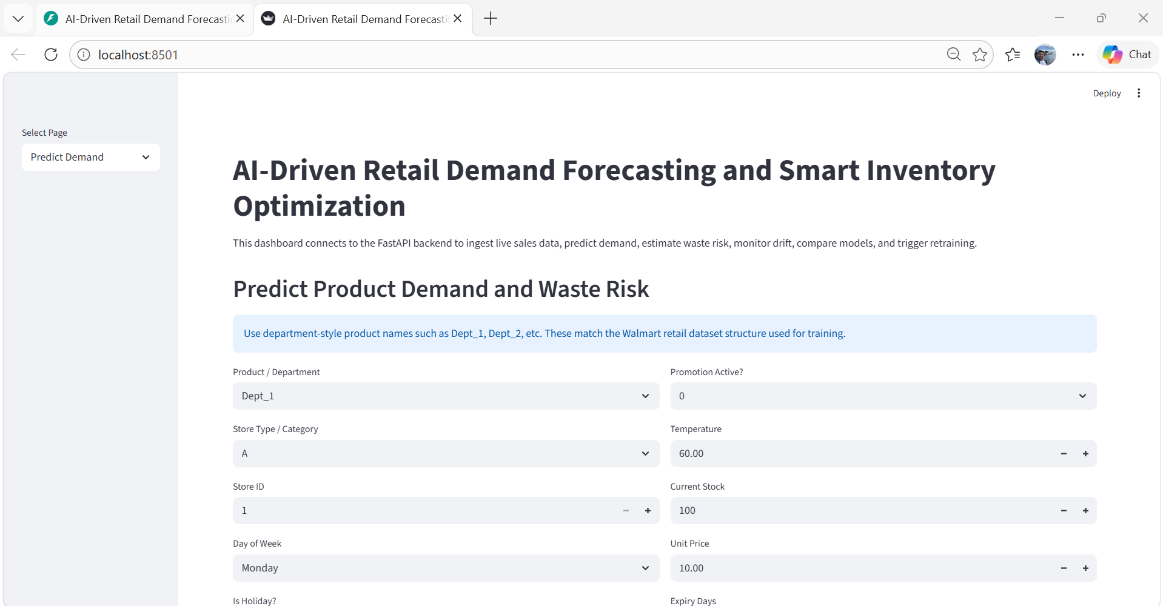
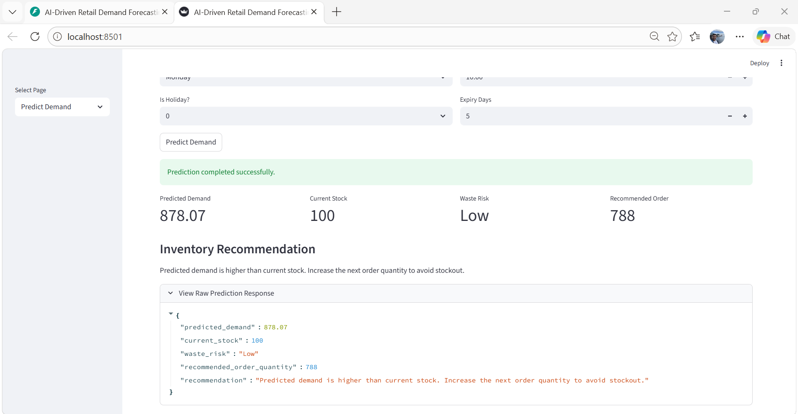
Figure 6: Streamlit dashboard showing demand prediction, waste risk level, and inventory recommendation.
The prediction interface demonstrates how machine learning outputs can support inventory optimization decisions in retail environments. By estimating future demand and identifying high waste-risk inventory situations, the system can help reduce unnecessary overstocking and improve stock planning efficiency. This type of operational forecasting may contribute to reducing avoidable food waste and improving resource utilization within retail supply chains.
A GitHub Actions workflow was added to support triggered pipeline validation and automated source-code checks during repository updates.
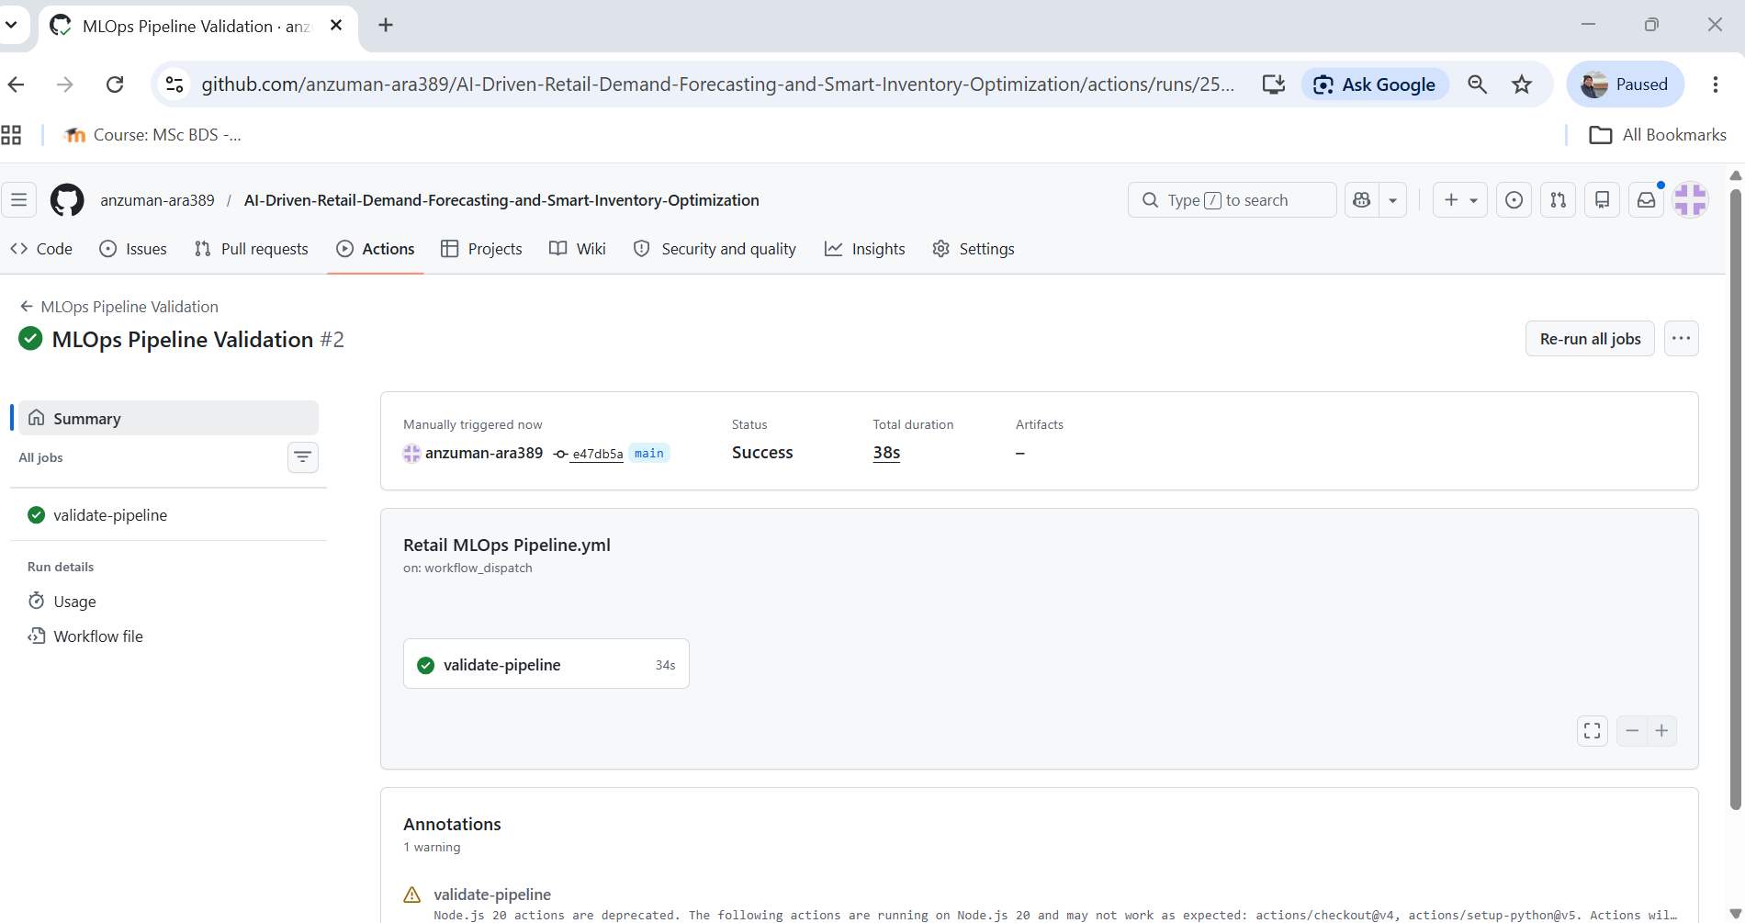
Figure 7: GitHub Actions workflow execution showing successful automated pipeline validation.

8. Limitations
The project uses synthetically generated inventory expiry and waste-related variables because such attributes were not available in the original Walmart dataset. In addition, the system uses lightweight statistical drift monitoring rather than enterprise-scale monitoring frameworks. Therefore, the results should be interpreted as a practical simulation rather than a fully deployed commercial retail system.

9. Future Work
Future improvements may include Kafka-based streaming ingestion, cloud deployment, Kubernetes orchestration, advanced concept drift detection, MLflow-based experiment tracking, and integration with real retail inventory systems containing actual expiry and waste data.

10. Conclusion
This project presented a practical MLOps pipeline for retail demand forecasting and inventory optimization. The system combined data ingestion, preprocessing, feature engineering, machine learning prediction, monitoring, drift detection, retraining, deployment, and dashboard visualization within a single workflow.
The project simulated how retail inventory data can continuously move through prediction and monitoring pipelines in a production-like environment. In addition, the implementation demonstrated how forecasting and inventory analysis may help reduce unnecessary overstock situations and support better stock planning decisions.
Overall, the project illustrates how MLOps techniques can be used to improve retail forecasting and inventory management in a practical environment.
References
Kreuzberger, D., Kühl, N., & Hirschl, S. (2023). Machine Learning Operations (MLOps): Overview, Definition, and Architecture. IEEE Access, 11, 31866–31879.
Schlegel, M., & Sattler, K.-U. (2022). Management of Machine Learning Lifecycle Artifacts: A Survey. SIGMOD Record, 51(4), 18–35.
Zha, D., Bhat, Z. P., Lai, K.-H., et al. (2025). Data-centric Artificial Intelligence: A Survey. ACM Computing Surveys, 57(5), Article 129.
Walmart Recruiting. (2014). Walmart Store Sales Forecasting Dataset. Kaggle. https://www.kaggle.com/competitions/walmart-recruiting-store-sales-forecasting

